# DRUG DATABASE

**A Project Report**

***Submitted by***

## SARANSH SINGH DHAPOLA(N021) SHOURYA GUPTA(N031) OMKAR DESHMUKH(N020)

***Under the Guidance of***

Prof. Vijayetha Thoday

***in partial fulfillment for the award of the degree of***

**MBATECH (DBMS)**

**IN BRANCH OF STUDY**

Computer engineering

At



**MPSTME, NMIMS.**

**November, 2022**

## DECLARATION

I, Saransh Singh Dhapola, Roll No. N021 MBATECH (Computer Engineering), III semester understand that plagiarism is defined as anyone or combination of the following:

1. Un-credited verbatim copying of individual sentences, paragraphs or illustration (such as graphs, diagrams, etc.) from any source, published or unpublished, including the internet.
2. Un-credited improper paraphrasing of pages paragraphs (changing a few words phrases, or rearranging the original sentence order)
3. Credited verbatim copying of a major portion of a paper (or thesis chapter) without clear delineation of who did wrote what. ( Source: IEEE, The institute, Dec. 2004)
4. I have made sure that all the ideas, expressions, graphs, diagrams, etc., that are not a result of my work, are properly credited. Long phrases or sentences that had to be used verbatim from published literature have been clearly identified using quotation marks.
5. I affirm that no portion of my work can be considered as plagiarism and I take full responsibility if such a complaint occurs. I understand fully well that the guide of the seminar/ project report may not be in a position to check for the possibility of such incidences of plagiarism in this body of work.

Signature of the Students: __________, _____________, ____________, ______________

Names: Saransh Singh Dhapola,Shourya Gupta,Omkar Deshmukh

Roll Nos. : N021,N031, N020

Place: Mumbai

Date: 9-11-22

## CERTIFICATE

This is to certify that the project entitled “Drug Database” is the bonafide work carried out by students of MBATECH MPSTME (NMIMS), Mumbai, during the III semester of the academic year 2022, in partial fulfillment of the requirements for the Course Database Management Systems.

___________________

Prof. Vijayetha Thoday

Internal Mentor

_______________________ ________________________

Examiner 1 Examiner 2

## Table of contents

**CHAPTER NO.**    **TITLE**

1. INTRODUCTION

SCOPE

PURPOSE

1. DESCRIPTION OF MODULES
2. DATABASE TABLES
3. DATABASE SCREENSHOTS
4. CONCLUSION & FUTURE SCOPE
5. APPLICATIONs IF ANY

**INTRODUCTION**

Our project consists of a backend in MYSQL as well as a Front-end in Python,using Tkinter.

The database consists of 4 tables,which were imported from the UN database in form of csv and imported using mysql queries.

The aim of this project is to provide a management system for Drug management.Each of the tables have been mapped using constraints such as primary and foreign keys thus allowing for a robust and scalable system.

**TABLES OF DATABASE**

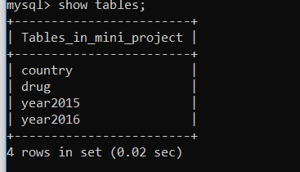

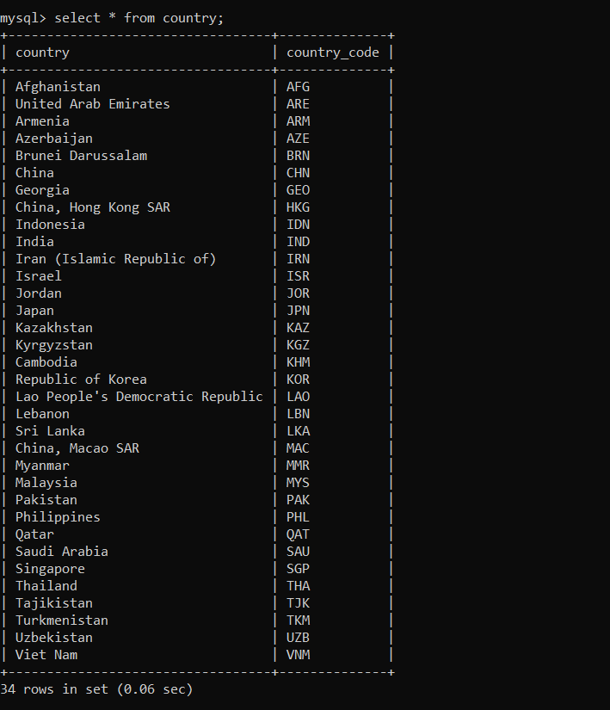

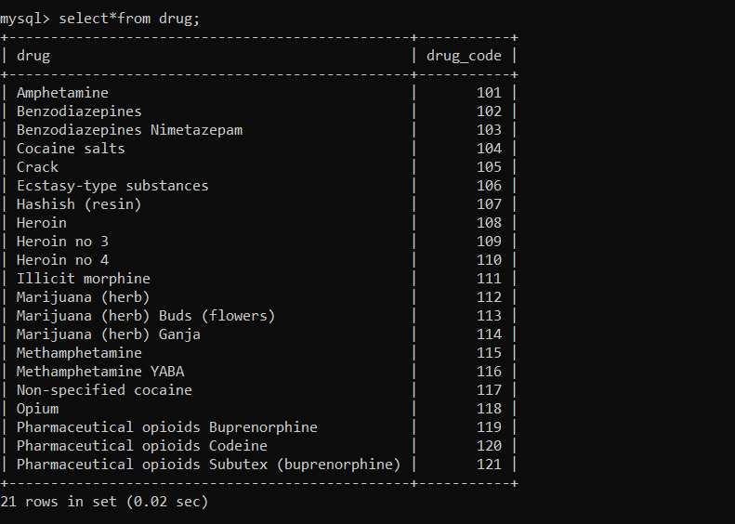

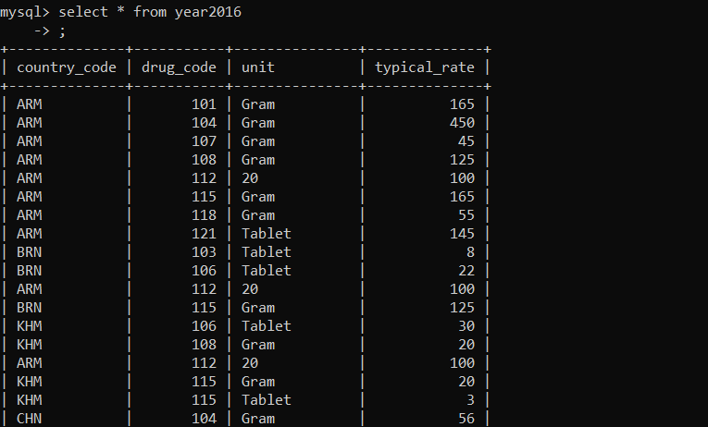

Table contains more records

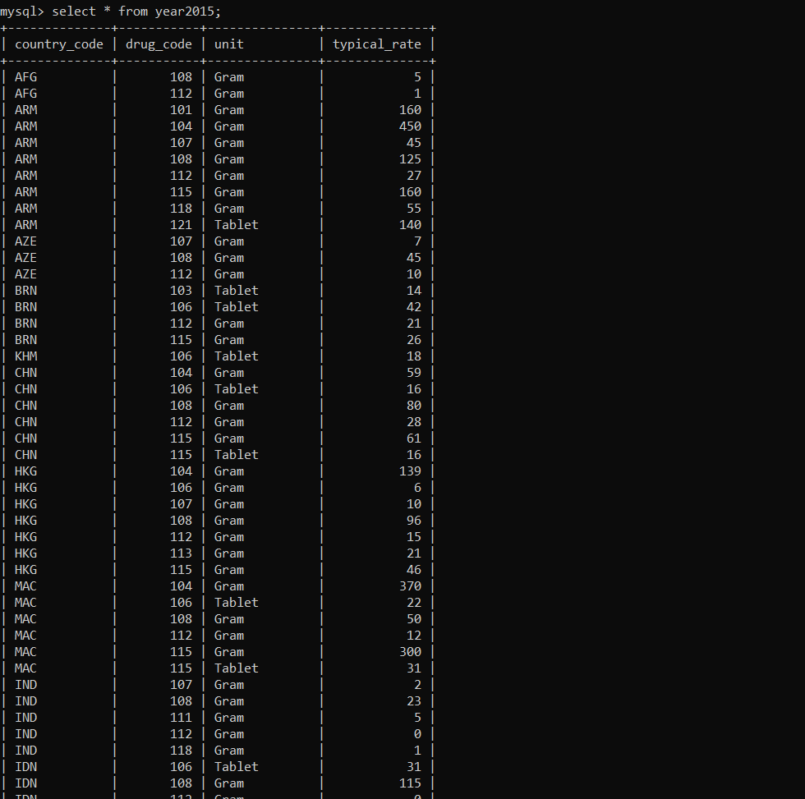

**FRONT END**

The available functions are:  
ADD()

UPDATE()

DELETE()

SELECT()

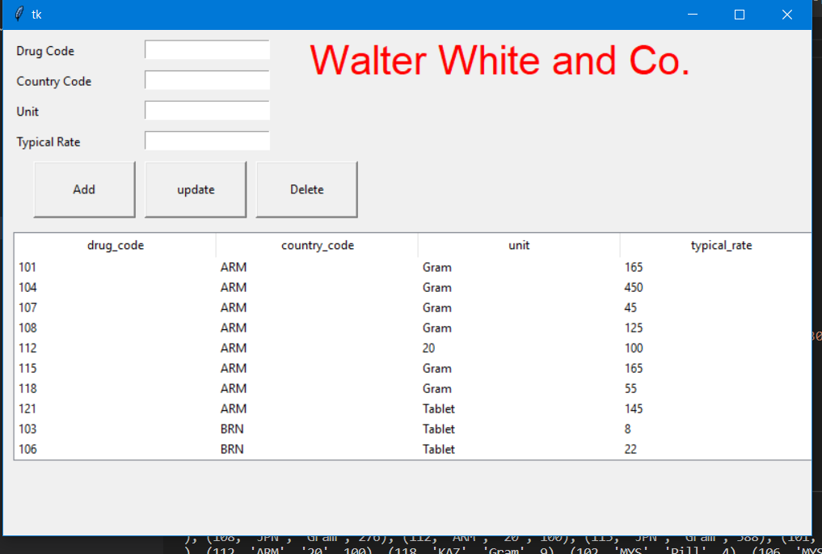

**The source code for this is available on:  
Github.com\Saransh-9174**

**Application & Future Scope**

This concept can be further expanded to multiple databases linking each of them together through python.

It can also be used as a management control system for drugs.The functional logic is well established therefore with some slight modification it can be made to suit any business need as well.

**APPLICATIONS FOR FRONTEND:**

1)MANAGEMENT SYSTEM

2)MONITORING SYSTEM